THE BOTHY AND THE ICEHOUSE
Fishing was a traditional industry in Nairn particularly for salmon, herring and white fish. Various methods were employed; line, drift netting and fixed nets being some examples.
Earl Cawdor who owned the land at Easter Delnies, established the Easter Delnies Fishing Station which operated until the formation of the Moray Firth Salmon Fishing Company in 1920.
At the height of the fishing there were five active bothies between Whiteness Head, about two miles to the west, and the mouth of the River Findhorn roughly 9 miles to the east. The Nairn Golf Club Bothy and Icehouse are acknowledged as the best-preserved example of their kind between here and Tugnet at the mouth of the River Spey, accordingly they are Category B listed buildings.
The Icehouse was built in order to keep the fish fresh until it was transported for sale. This is of classical design, partly underground with thick walls and covered with turf. A small window at the back was where the ice was brought in. There is a heavy timber door which separates the barrel-vaulted inner chamber from the entrance. The ice came from nearby rivers or specially created ponds.
Local tradition infers that there was a Roman Fort at Delnies. This is based on the discovery of an urn containing the coins of several different Emperors. It is sometimes speculated that the icehouse was built into the hillock where the fort once stood, sadly there is no hard evidence to support this, but it is a fascinating thought!

Easter Delnies Fishing Station
The date on the Icehouse is 1877 so it is reasonable to assume that the fishing station consisting of the Bothy, to house the fishermen, and the Icehouse, to store the ice were constructed around that time.
The first edition 6- inch ordnance survey (OS) map surveyed in 1868-9 confirms the fishing station did not exist at that point.

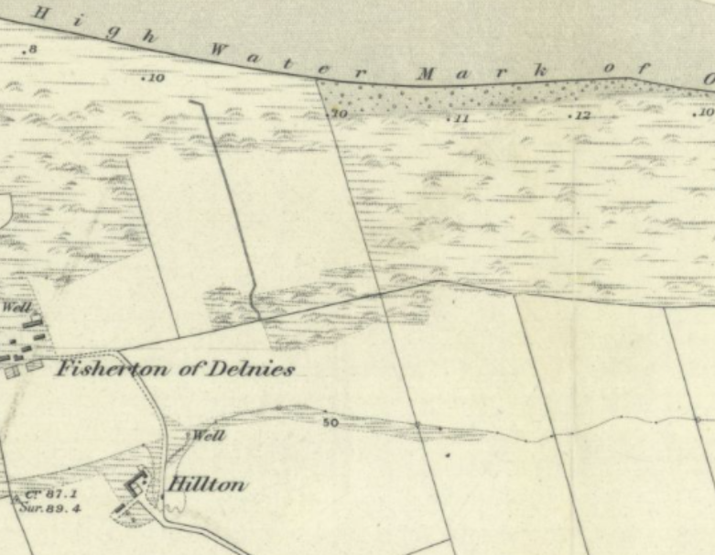
1868-69 map showing no Bothy or Icehouse.

The first map produced after the fishing station was established in 1877 is the second edition of the 1-inch OS map, revised in 1894 and published in 1896.

Bothy Icehouse
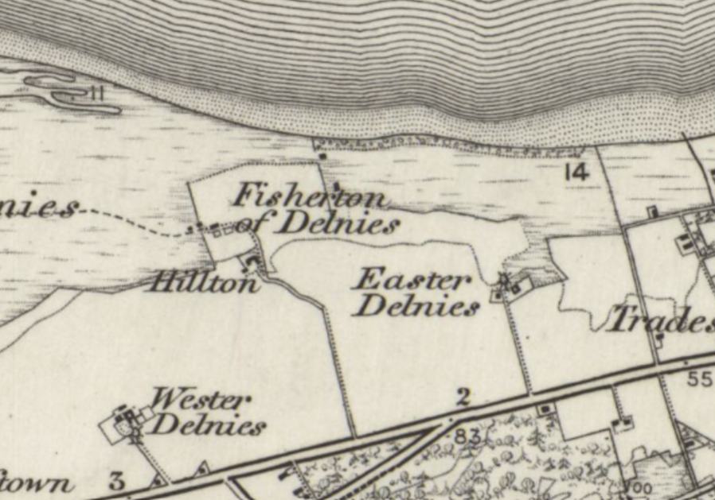
1894 map now showing the Bothy and the Icehouse clearly separate.

It is of great interest to note that the Bothy is clearly shown well to the north of the Icehouse.

In 1897 Horace Hutchinson published his classic “British Links Golf”. On pages 269-278 he gives a detailed account of the Nairn course as it was at that time. The furthest west hole was “The End”, on p276 there is a photograph entitled “End Hole and Fisherman’s Hut” which is clearly the Bothy but with no sign of the Icehouse which implies that the bothy was, as one would expect from the OS map evidence, on its original site when this picture was taken.

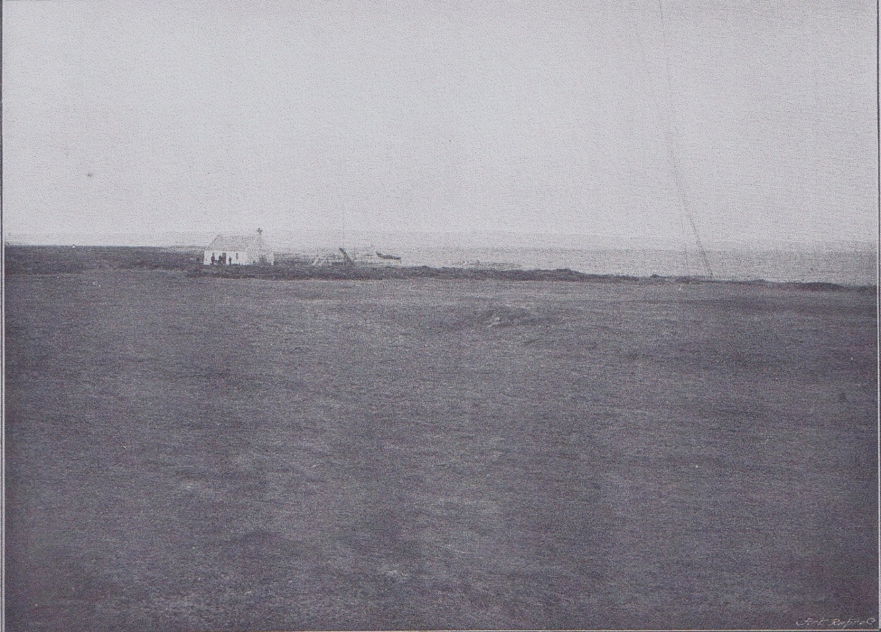
Picture from H Hutchinson’s 1897 book, the Bothy can just be made out in the top left.

The minute of lease between Earl Cawdor and the Nairn Golf Club dated 1899 gives conclusive evidence as to the relative sites of the Bothy and the Icehouse at that time:
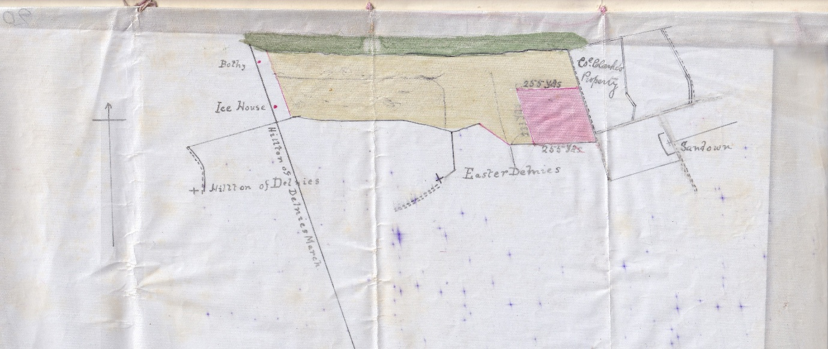
The 1899 lease agreement clearly shows the Bothy and the Icehouse in their original positions.

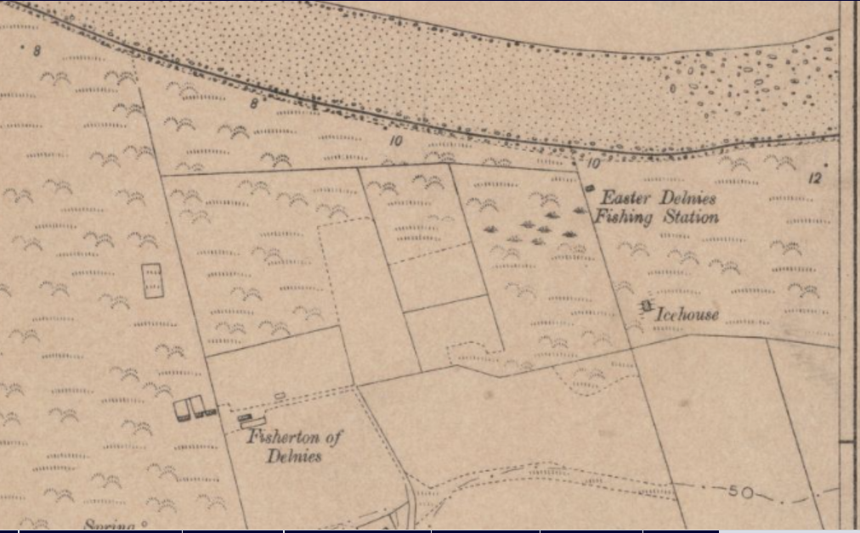
The 1904 map shows the Bothy and Icehouse as originally sited i.e. the Bothy marked as “Easter Delnies Fishing Station” is to the North.
The 1904 edition of the six-inch map again shows the original layout.

Fascinatingly the third edition of the one-inch map, revised 1908-09 shows the Bothy has now been moved to its current position adjacent to the Icehouse.

Bothy and Icehouse now situated together
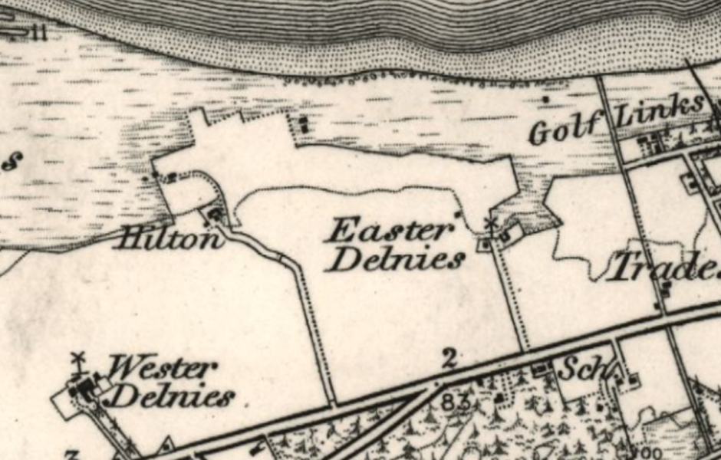
1908-09 map showing that the Bothy has now been moved to its present site.

This would clearly imply that between 1904 and 1909 the Bothy was moved to its current position.

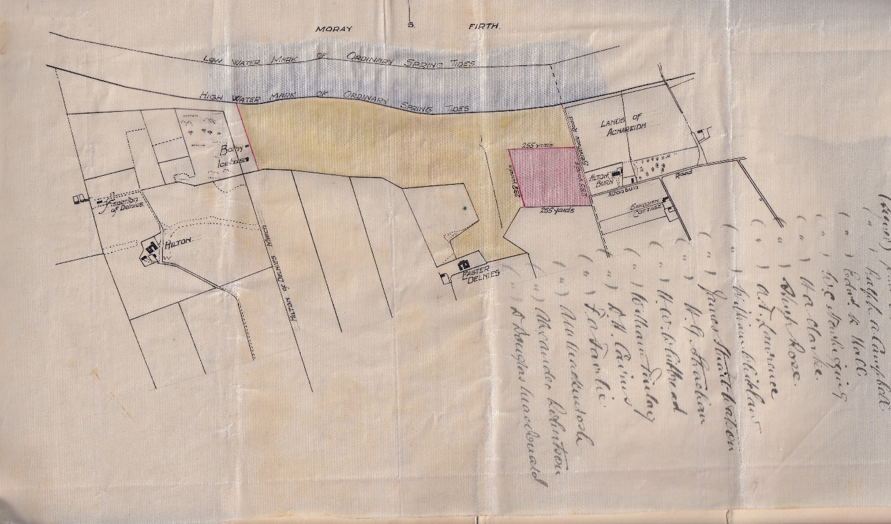
Lord Cawdor’s 1919 lease now clearly shows the current set up.

Further evidence of the Bothy having been reassembled comes from several of the joists in the ceiling showing signs of having been rebated or notched at an angle as if they had been used before on a slightly wider roof structure.
One can only speculate that the move was necessitated by coastal erosion, a problem which continues to this day?

The function of the Bothy.
The Bothy was built to accommodate the fishermen who lived there through the fishing season, four or five men would have lived there at a time. They fished from their coble boats and from fixed nets. The remains of the wooden uprights of the nets can be seen today at low tide. In a good season the fishing station would supply over 5000 salmon. The Bothy is of a standard design with a low ceiling, a fireplace and originally would have had an attic space.

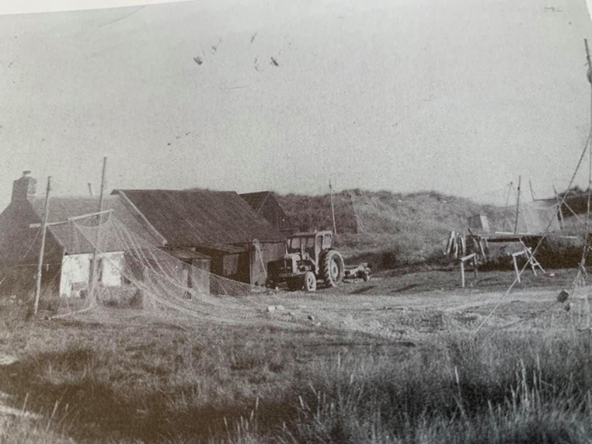
An example of a working salmon fishers’ bothy (not the NGC one unfortunately). The nets are drying; the tractor would be used to pull the coble in and out of the sea.

Older members of the Club recall that they could order a salmon from the bothy whilst golfing and it would be delivered to their homes later that day, service indeed!

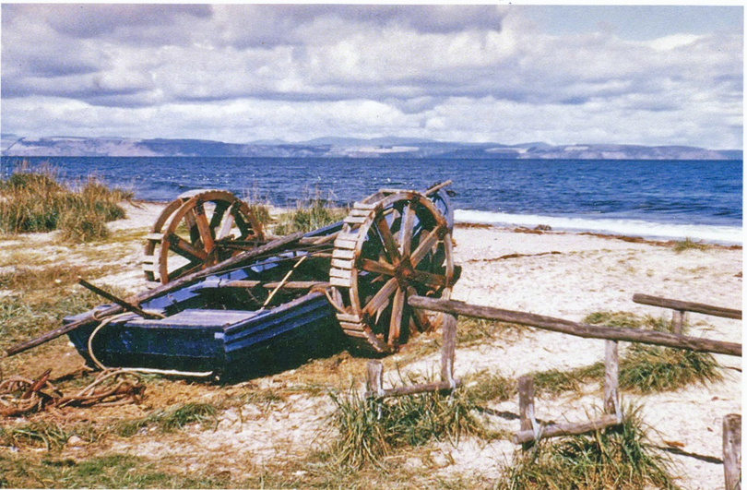
The last coble to serve the bothy, it was eventually motorised and moved to the harbour.

With the general decline in salmon stocks and netting rights being gradually purchased to protect valuable river fishing, the bothy eventually became defunct in the 1980s.
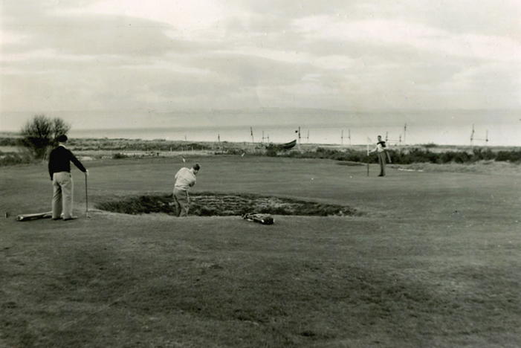
A view of the 9th green in 1949 with the salmon fishers’ coble boat and the nets in the background.

Fishertown of Delnies
Nearby was a small settlement known as “Fishertown of Delnies” where the original fishing folk lived.
This settlement was in existence long before the Bothy and Icehouse were built. It appears on General Roy’s map of 1747-55 as five clusters of buildings, so it was a reasonably sized settlement.
Fishertown of Delnies
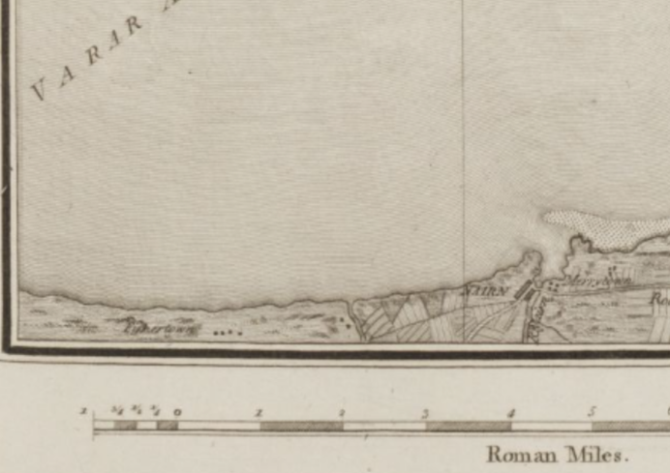
General Roy’s 1747-55 map. Fishertown can just be made out on the lower left.

The men fished whilst the women tended the croft lands and then wandered through Nairnshire selling the fish, we cannot imagine how hard a life that must have been! Perhaps some of them worked at the Easter Delnies Fishing Station as the land was all owned by Earl Cawdor.
Little remains of Fishertown of Delnies, other than a single building just visible from the 10th Championship tee. Apparently, it became too difficult to land and store the catch, the reasons why are unclear. In any case, the original Nairn harbour, designed by Thomas Telford in 1821, was rebuilt and extended in 1932 which would have provided a much better landing spot for the herring and white fish catches.

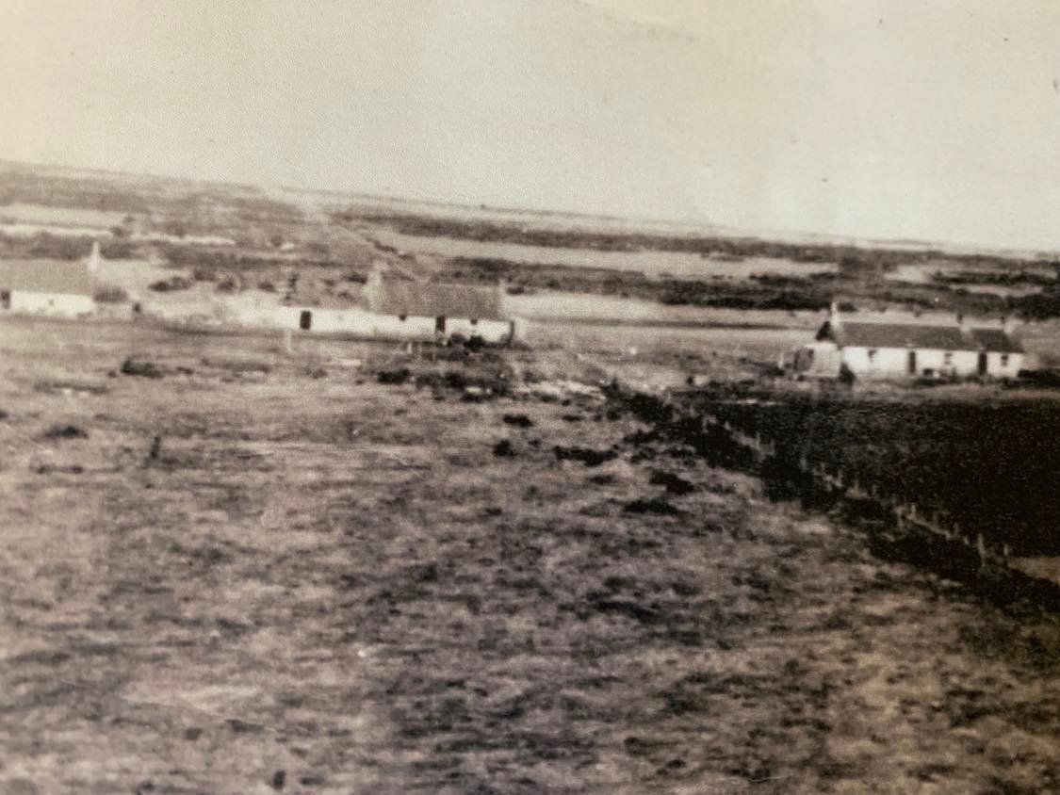
Fishertown of Delnies, houses belong to (L-R): The Morgans, Mrs Isobel Paterson, the Proctors.

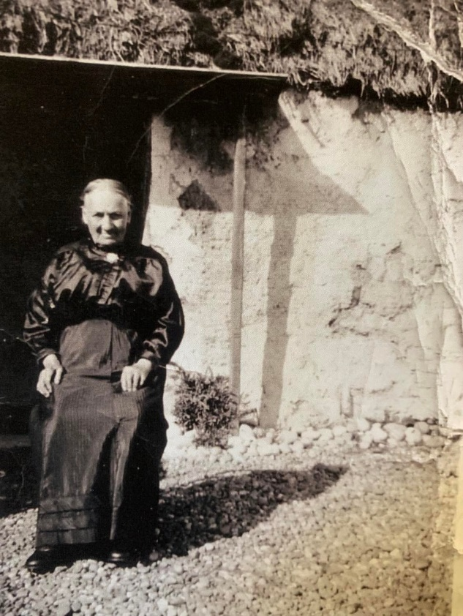
Mrs Isobel Paterson taken July 1939.

Recent History
The Bothy and Icehouse remained part of Cawdor estate whilst there was viable salmon fishing. The end of that industry in the 1980s gave the Club the opportunity to purchase the buildings and their surrounds. This was done in 1988 at a cost of £10,000.
Over the winter of 2024-25 the bothy has been fully restored; the original wooden flooring, which was simply laid on the ground and hence prone to damp, has been replaced by handsome stone flags and the walls have been taken back to the bare stone giving an authentic feel to this great asset for Nairn Golf Club.
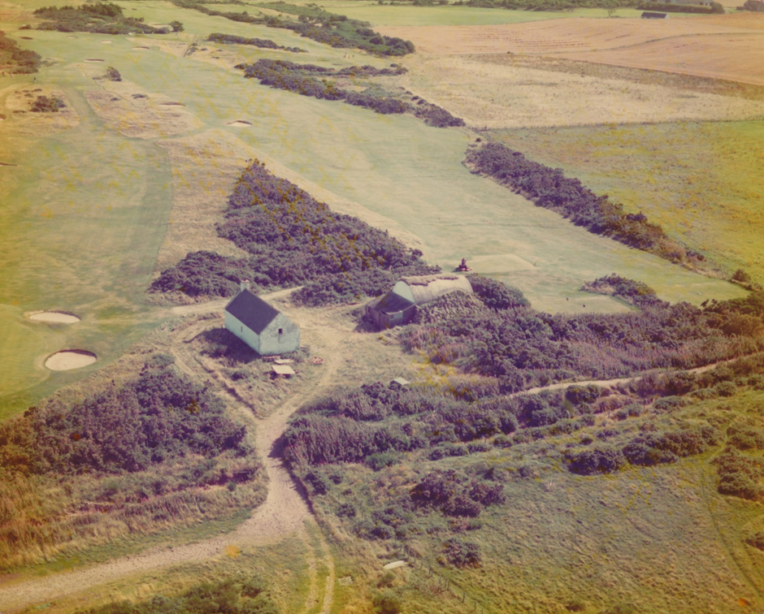
The Bothy and Icehouse prior to restoration.

Sources of information
History of Nairnshire; George Bain, 2nd Edition facsimile 1996.
Nairn Museum Facebook page.

Historic Environment Scotland: Delnies Icehouse and Bothy, The Nairn Golf Club, NairnLB52544.

Highland Historic Environmental Record; MHG62648 - Bothy - Delnies, Nairn Golf Course.
National Library of Scotland, Ordnance Survey Maps.
Nairn Golf Club Archives.
Horace Hutchinson, British Golf Links, London, 1897.

Nairn Golf Club Archives
August 2025

Addendum: This paper was submitted to Historic Environment Scotland who have agreed with the contention that the Bothy has been moved from its original position and are updating their records accordingly.

